Recspicy Document 3 - User Guide

https://recspicy.onrender.com

By:
James McGugian
&
Steven Foster

Table of Contents
Introduction 3
System Overview 4
Document Overview 4
System Description 5
Overview 5
Key Features 5
Software & Hardware Requirements 6
Software: 6
Hardware: 6
Accessing the System 7
System Organization & Navigation 7
Operational Scenarios 7
Using Create Recipe 8
Technical Instructions 8
Website Manual 9
Welcome Landing Page 9
Sign Up Page 10
Sign In Page 11
Profile Page 12
Edit Profile 13
Home Page 14
Recipe Display 16
Recipe Search 17
Favoriting System 18
Meal Planner 19
Admin Analytics & Support 20
Feedback Page 20
Contact Us Page 21
Troubleshooting FAQ & Support 22
Terms & Privacy Agreements 24
Error Messages 25
State of the System as Delivered 26
Future Improvements 26
Appendix 27
Appendix A: References 27
Appendix B: Key Terms 27


Introduction
Recspicy is a website designed for the purpose of simplicity for the user, what we intended for implementation is the process of recipe management and meal planning for all users interested in a recipe platform that is both simple to navigate and customize while, having both features for profile building through various intended means and recipe creation through our platform for more active users. The website allows users to organize and discover varieties of recipes, intended for self management for current and future use. Our standpoint on why we decided on Recspicy as a project was due to the inconsistencies and difficulties brought on by other recipe platforms.
Our goal is to fix these flaws mainly by working toward our own intentions of user management, most recipe websites have traffic through there platform with users only intended goal as, search their intended recipe, print the recipe, and the transaction ends commonly at this point. Recspicy as we worked and developed this platform, has intentions based past this common practice of find a recipe print a recipe, we are looking for user engagement, we want profiles, we want meal plans, we want users to feel comfortable creating recipes and saving them knowing that a family recipe is private to them and stored on our platform with no ill intentions of stealing it.
We want users to feel engaged enough to find comfort in sharing their own created recipes for many other users to view through our system or find recipes that they will want and use in the future for their own intended purpose. Recspicy as a platform simplifies the collection and management of recipes, making meal preparation, recipe creation, and recipe allocation both efficient and enjoyable. The system is engineered to support a diverse user base, ensuring both data integrity and user privacy.

System Overview
Recspicy is a web platform developed in HTML, CSS, and Javascript frontend, Node.js and Express for the backend, and MongoDB/Atlas for data storage. The backend connections are built on a REST premise that facilitate secure data processing, and the frontend updates these stored and called upon bits of information and creates dynamic interaction and visualization based on designs for user experience. The web architecture is designed for scalability, supporting a growing number of users and recipes minimal risk to compromising performance. Our build includes recipe storage, user authentication, database management and information creation and retrieval and the system’s design allows for easy maintenance and future enhancement.

[put image of sys arct. Here as a UML ]

Document Overview
This document is intended as a comprehensive user guide to the Recspicy website. We are writing this paper in a way to verbally and visually show the design to support a wide range of users, including developers, administrators, and general users. This document includes technical information-such as API details, database structures, clear instructions for navigating the site and making the most of its intended features. We include sections on operational guidelines, troubleshooting, and best practices for contact to create an ideal user experience.
We’ve made a point to use straightforward language in our pages for consistent terminology throughout this project. We want this guide to be easy and accessible to both technical and non-technical readers. Screenshots and diagrams are included to clarify key processes and concepts through our process and with this our project follows clear instructions for user guidance and assistance.

System Description

Overview
The Recspicy system is designed with multiple factors of support such as a client & server based architecture for information supported for beneficial user experience, we provide a system for user authentication for both typical web support and profile entry and we include quality of life features such as single sign on “SSO” capabilities with the support of google. The backend utilizes Node.js and Express for communication and support of our server and API endpoints are managed for web resource and business logic, MongoDB/Atlas stores recipes and user profiles and additional other forms of profile related information in a document-oriented format for ease of support. The frontend uses authentication pages, recipe management interfaces, and meal planning tools. Security restrictions on user authentication are enforced through JWT authentication, ensuring that only authorized users can access their own data as it is created and stored. Logging and analytics features provide insights into system activity, supporting ongoing maintenance and improvement. Administrative tools enable user management and content moderation, ensuring a safe and engaging environment for all users.

Key Features
- User Authentication: Sign up & Sign in Functionalities with profile creation and Update Capabilities.
- Recipe Management: Create, edit, and search for recipes using filters and tags to easily find and organize recipes.
- Meal Planner: Schedule meals and coordinate your meal plans.
- Favorites System: Save & organize a collection of your favorite recipes for quick access.
- Administrative Dashboard: Access analytics and manage users with a dashboard designed for administrators.
- Security: Protect user data and system integrity with JWT authentication.

Software & Hardware Requirements
To run Recspicy, users and developers need a system equipped with Node.js and MongoDB. A minimum of 2GB RAM and 500MB of disk space when managing large recipe databases. Our platform operates entirely on a web interface this means it does not require any specific hardware except for a standard web browser and network connection.

Software:
- Languages: HTML CSS & JavaScript for frontend, Node.js for backend
- Database: MongoDB/Atlas a NoSQL for data storage
- Hosting Platforms: Fill This in snowyranger8@gmail.com
- Version Control: Git for source code management, hosted on GitHub
- APIs: RESTful API for server-client communication

Hardware:
- Development Environment: VS Code, Notepad ++
- User Devices: web browsers like Chrome, Firefox, Safari

Accessing the System
Accessing Recspicy is a straightforward approach. On our website, users navigate to the platform at the server address https://recspicy.onrender.com. New users can register an account from the sign-up page, creating a secure account with verified credentials. Admins have access to features like analytics for web traffic and management tools, which are protected by privileged authentication.

System Organization & Navigation
Recspicy’s user interface is designed for clarity to new and coming users and is developed with intended features to create a ease of use system. Main navigation elements include the landing page, authentication sections, dashboard, and recipe management areas. Secondary menus provide quick access to user profiles, settings, and help resources. Consistent layout patterns and visual cues are used throughout the platform to create a familiar navigation and enhanced user experience. Search functionality and filtering options help users quickly locate recipes from both users and from our resource in an easy manner, even within the large scale of these recipe collections. Accessibility considerations ensure that all users, regardless of ability, can navigate the system easily and effectively with assistance provided in the FAQ and Contact.

Operational Scenarios
Recspicy supports a variety of operational scenarios such as new users typically begin by creating an account and setting up their profile with a bio and an image. After profile creation regular users can use our search, create recipes, and utilize our meal plan feature. The platform allows users to share recipes both publicly and privately with our database, this allows users to share recipes with our community. Administrators monitor and manage user accounts, and address issues necessary for support through means of contact and email. Support scenarios include password recovery, feedback, and troubleshooting, all with strict adherence to data privacy and security..

Using Create Recipe
The recipe creation feature in Recspicy is designed to capture all necessary details for a user to share in their own way family recipes and create recipes to our platform or for their own personal use. Users can enter a recipe title, description, preparation time, and detailed ingredient lists with quantities and units. Step-by-step instructions allow users to uniquely describe their own recipes in a text formatting with image uploads, this is done so users can take the time to improve clarity and these recipes will be editable so users can improve them over time. Tags and meal categories are attached to these created recipes and are there to improve recipe discoverability through advanced search filters that are dependent on user engagement with our website for publicly shared created recipes. Users can preview their recipes, and post, change or remove recipes they create allowing for flexibility within their profiles and with the recipe creation system. Tooltips are available throughout the form to assist users in providing complete and accurate information

Technical Instructions
The Technical aspects of this platform range from the API documentation specifying endpoint URLs, request and response formats, and authentication requirements. Environment variables manage database connections and security settings, while the build process compiles frontend assets during the website's deployment. This is a web platform following standard setup and domain hosting any changes will be through the developers for assistance the contact form will allow these to take place.

Website Manual

Welcome Landing Page
The landing page of Recspicy serves as the primary entry point for new and returning users. It provides an overview of the platform’s features and clear calls-to-action for registration and login. Information for profile utilization and access are provided on these pages the utilization of a profile system is our sales point for this project while making navigation easy and simple.
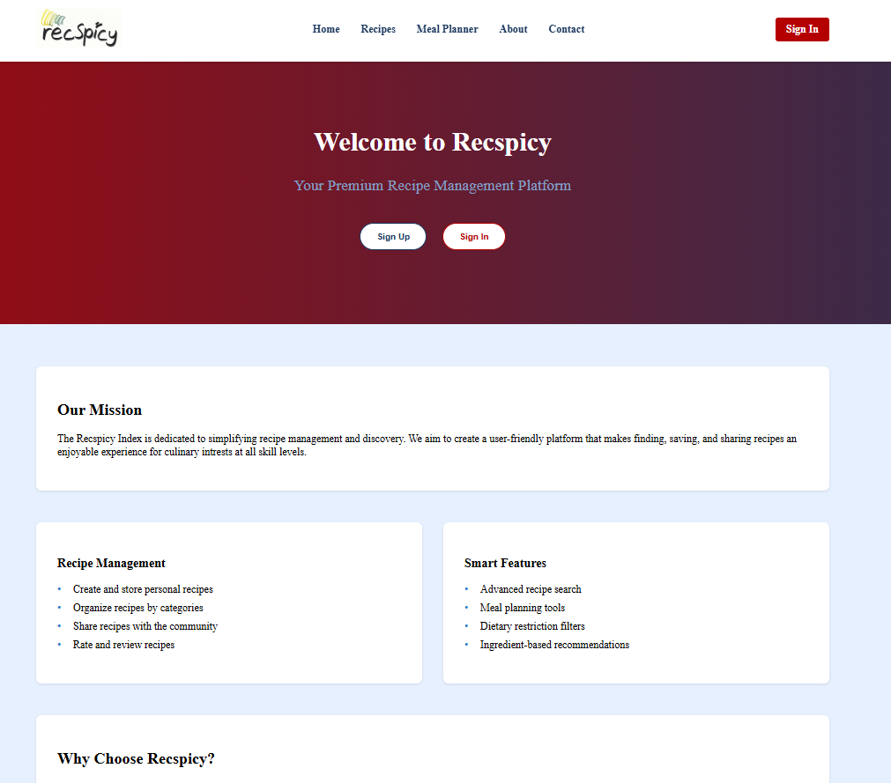

Sign Up Page
The sign-up page guides new users through the registration process, collecting essential information such as email, password, and basic profile details. Real-time validation ensures that passwords are strong and email addresses are correctly formatted. Users must accept the terms of service and privacy policy before completing registration, the access to terms and privacies will be provided in a hyperlink next to the check box or at the bottom of the page in the footer section. Upon successful sign-up, an email verification step enhances account security.
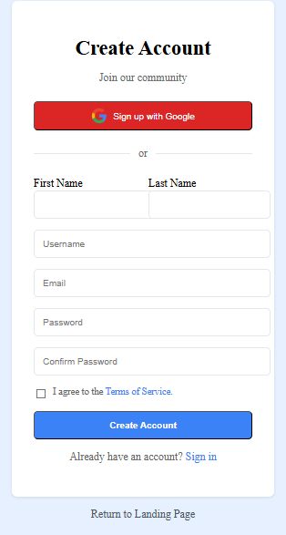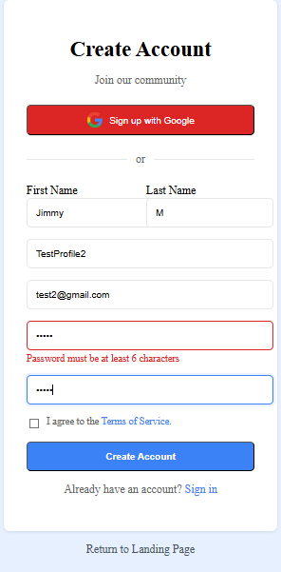

Sign In Page
The sign-in page provides a secure authentication process, requiring users to enter a verified email address and password. If users forget their credentials, password reset options are readily available. The system supports session management, allowing users to remain logged in across browser sessions. Security measures, such as account lockout after multiple failed attempts and optional multi-factor authentication, protect against unauthorized access. The interface maintains a consistent look and feel with the rest of the platform.
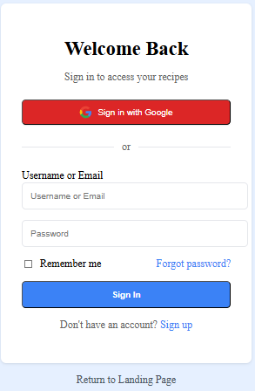

Profile Page
Each user has a personalized profile page displaying their information, activity statistics, and preferences. Privacy controls allow users to manage what details are visible to others. Achievement badges recognize active participation and contributions to the recipe community. Users can upload and edit profile pictures, with automatic cropping and optimization for consistency. Account settings include options for managing email notifications and privacy preferences, and all changes require password confirmation for security.

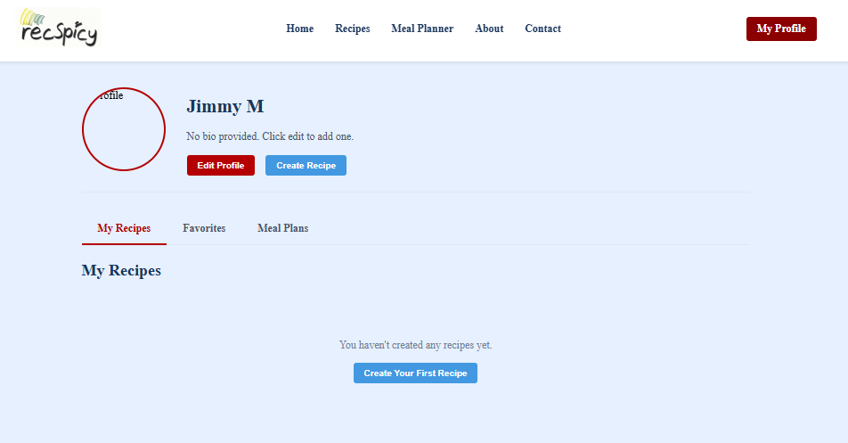

Edit Profile
The edit profile section enables users to update their personal information through user-friendly, validated forms. Changes can be saved automatically or require explicit confirmation, depending on the sensitivity of the data. Users can review and restore previous versions of their profile information if needed. The interface also allows for the management of connected social media accounts. Profile completion indicators encourage users to provide comprehensive information, and all edits adhere to the platform’s accessibility standard.
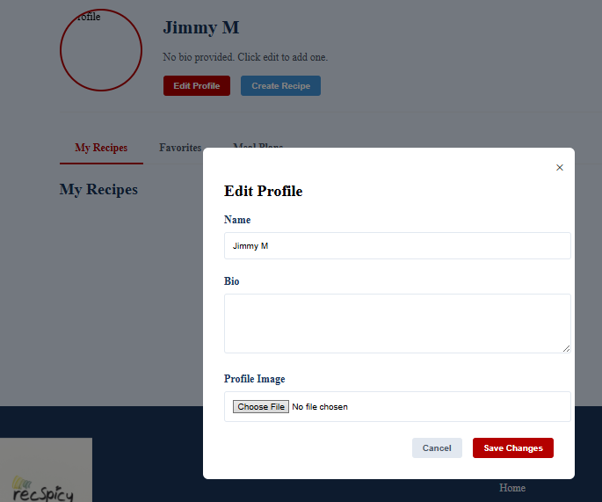


Home Page
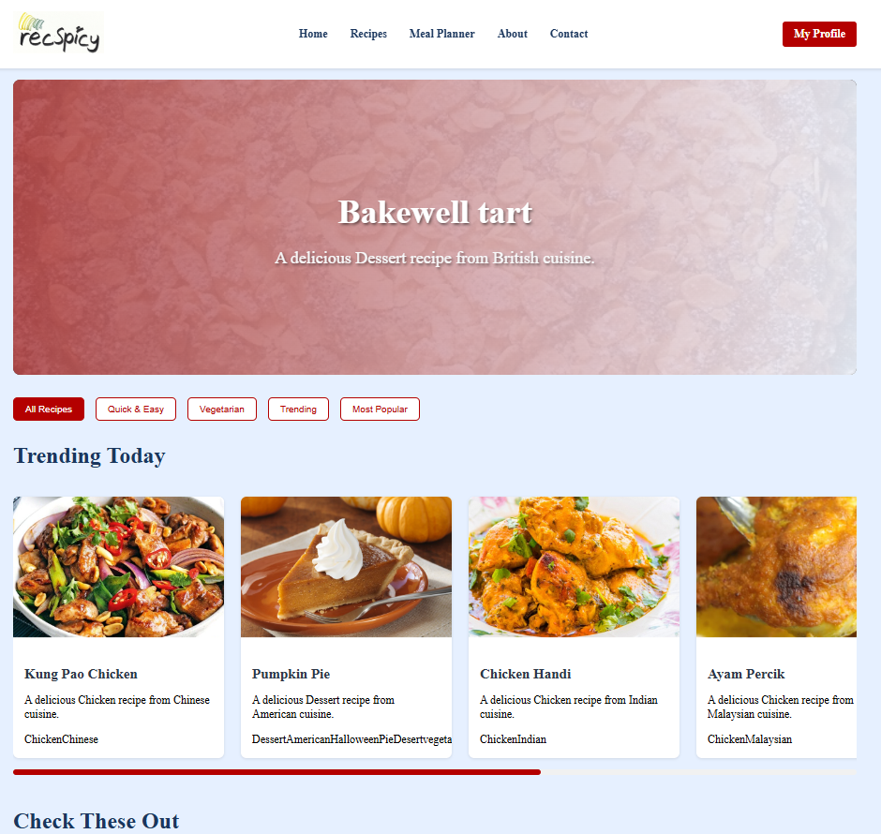
The home page acts as a personalized dashboard, providing users with tailored content based on their preferences and activity history. Recipe recommendations take into account dietary restrictions and past favorites, while meal planning widgets display upcoming preparations and shopping needs. The activity feed keeps users informed about recent updates and contributions from friends. Quick-access tools streamline common actions, and the layout can be customized to prioritize the most relevant information for each user.

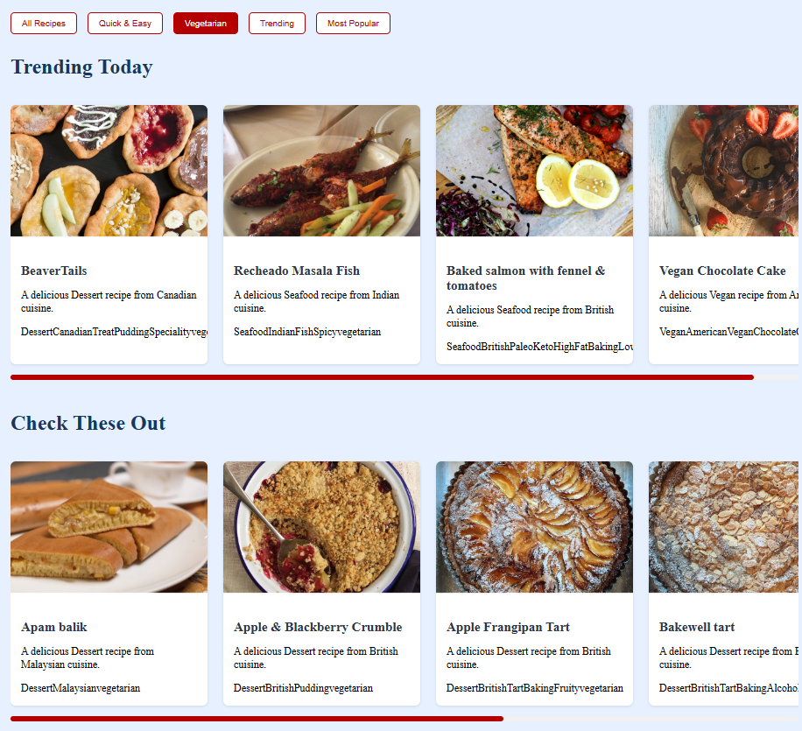

Recipe Display
The recipe display page presents all the details of a selected recipe in an organized and interactive format. Ingredients are listed with checkboxes for tracking preparation progress, and step-by-step instructions include timers and progress indicators. User ratings and comments offer social validation and helpful tips. Nutritional information is provided when available, and serving size calculators adjust ingredient quantities. Users can print or export recipes for offline use, enhancing convenience.

Recipe Search
The recipe search feature allows users to find recipes using a variety of criteria, including ingredients, cooking time, and difficulty level. Autocomplete suggestions help users quickly enter search terms, and recent or saved searches can be accessed for convenience. Search results update dynamically as filters are applied, and voice input is supported on compatible devices. This advanced search functionality makes it easy to locate specific recipes within large collections.
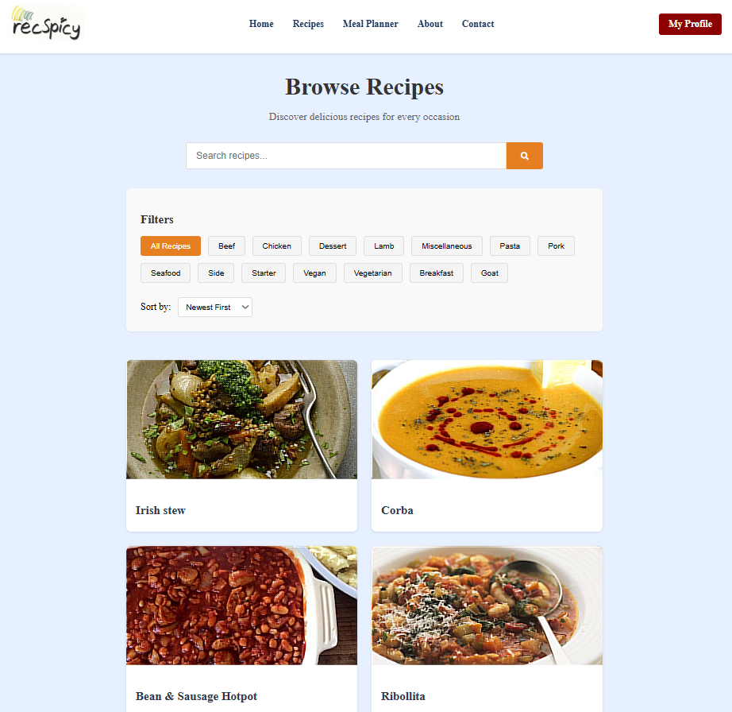

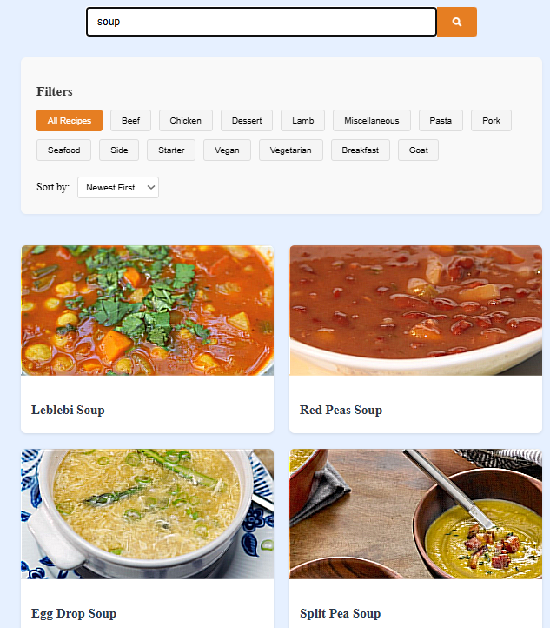

Favoriting System
The favoriting system allows users to bookmark and organize their favorite recipes into customizable collections. Users can label and share these collections, enabling collaborative curation with friends or family. Smart collections automatically include recipes that match specified criteria, and favorites are synced across devices via cloud storage. Export options are available for transferring collections to other applications, and visual indicators highlight popular recipes among the user community.

Meal Planner
The meal planner provides an interactive calendar for scheduling meals and managing weekly plans. Users can drag and drop recipes onto specific dates, and the system automatically generates shopping lists based on planned meals. Family meal plans can be shared with household members, and preparation reminders help users stay organized. Nutritional summaries assist in balancing meals according to dietary goals, making meal planning both efficient and health-conscious.
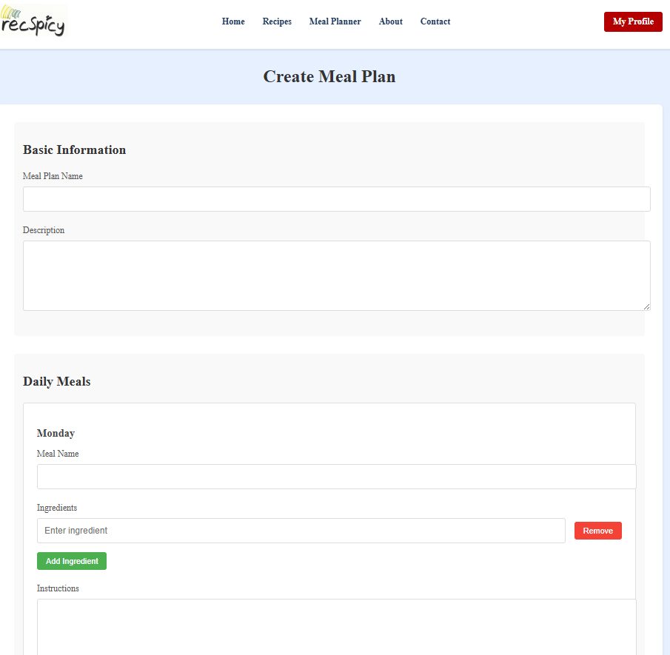

Admin Analytics & Support
Administrative users have access to analytics dashboards that track system usage, popular recipes, and overall performance. User management tools enable account moderation and privilege assignment, while content review interfaces help flag and evaluate potentially inappropriate recipes. System configuration options allow administrators to control feature availability and default settings. Backup and restore functions protect against data loss, and all administrative actions are logged for accountability and auditing purposes.
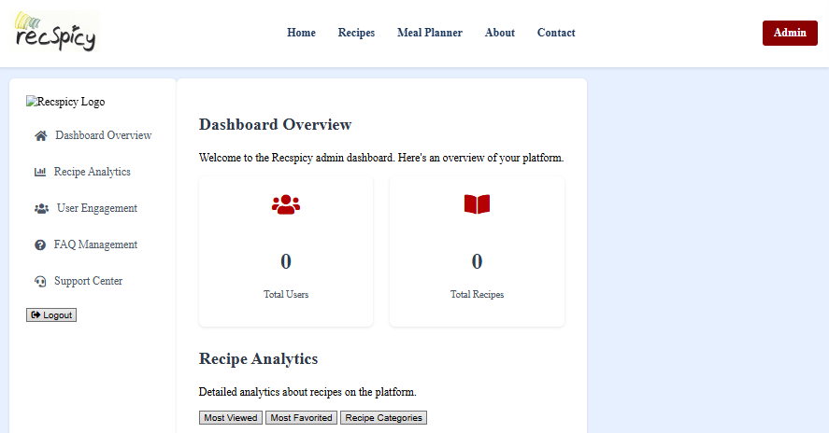

Feedback Page
The feedback page provides structured forms for users to submit suggestions, report issues, or request new features. Feedback is categorized to ensure it reaches the appropriate support team, and users can attach screenshots or other documentation to clarify their concerns. Status tracking allows users to monitor the progress of their feedback submissions, and common solutions are suggested dynamically based on the nature of the problem. Contributors are recognized for providing valuable input that helps improve the platform.

Where is feedback in project and place image here

Contact Us Page
The contact page is a customer support feature which offers a comprehensive knowledge base with articles addressing frequently asked questions and common issues. Users can submit support tickets for more complex problems, and live chat is available during business hours for real-time assistance. Community forums facilitate peer-to-peer support, and service status indicators provide updates on system availability. Escalation procedures are in place to ensure that critical issues are resolved promptly and efficiently.
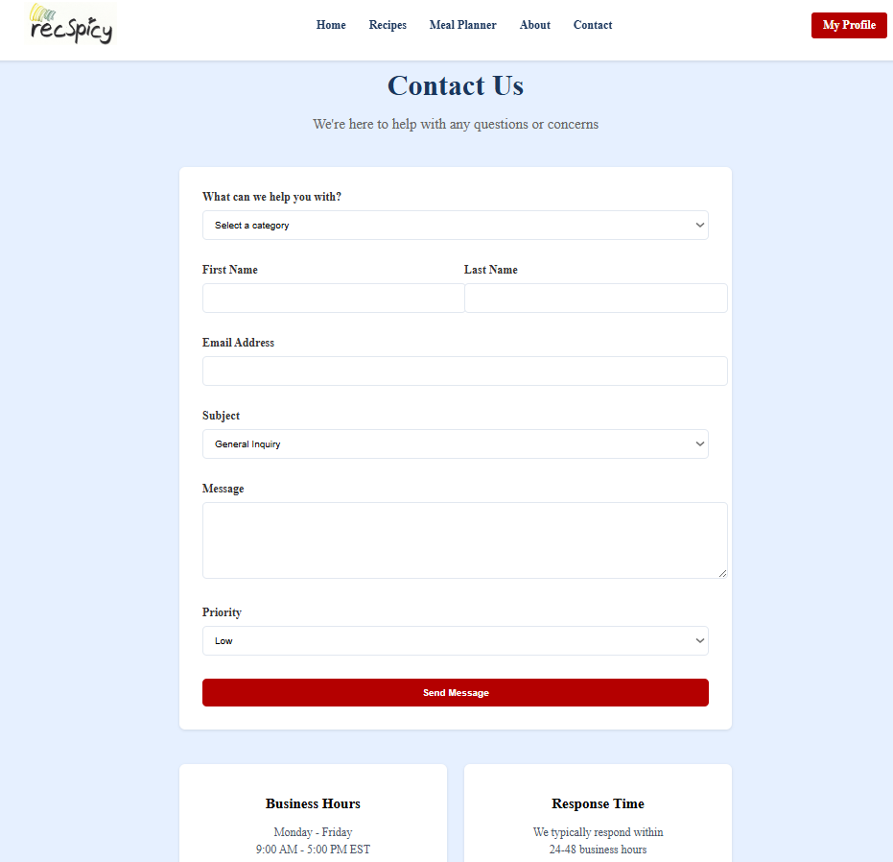

Troubleshooting FAQ & Support
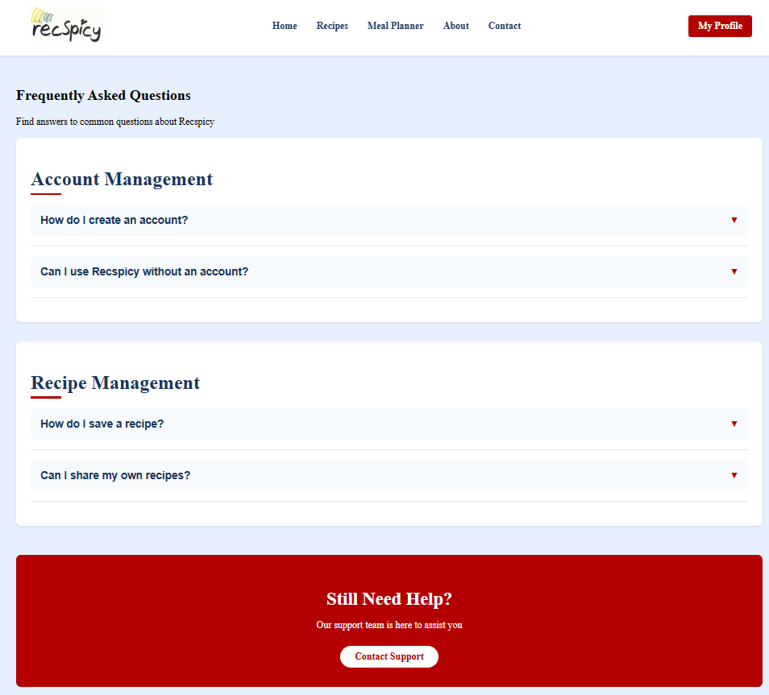
The troubleshooting section provides solutions to common issues such as browser compatibility problems, forgotten passwords, and connectivity errors. Step-by-step instructions guide users through standard resolution procedures, while advanced troubleshooting covers server configuration and database maintenance. Support contact information is readily available, and users are encouraged to participate in community forums for additional assistance. Critical system alerts are communicated to administrators to ensure rapid response to emerging issues, maintaining system stability and user satisfaction.
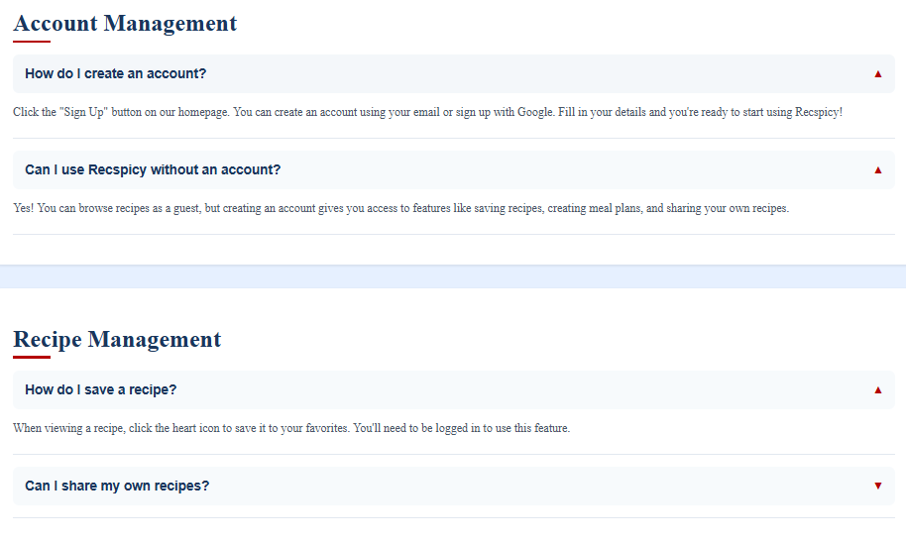

Terms & Privacy Agreements
The Terms and Privacies page is utilized for the user agreement policies and terms provided by recspicy to the user this is for user data protection and information security between users. Agreement to these policies ensure users are using best practices when accessing our site and is implemented to prevent and deter information theft and unwanted entry.
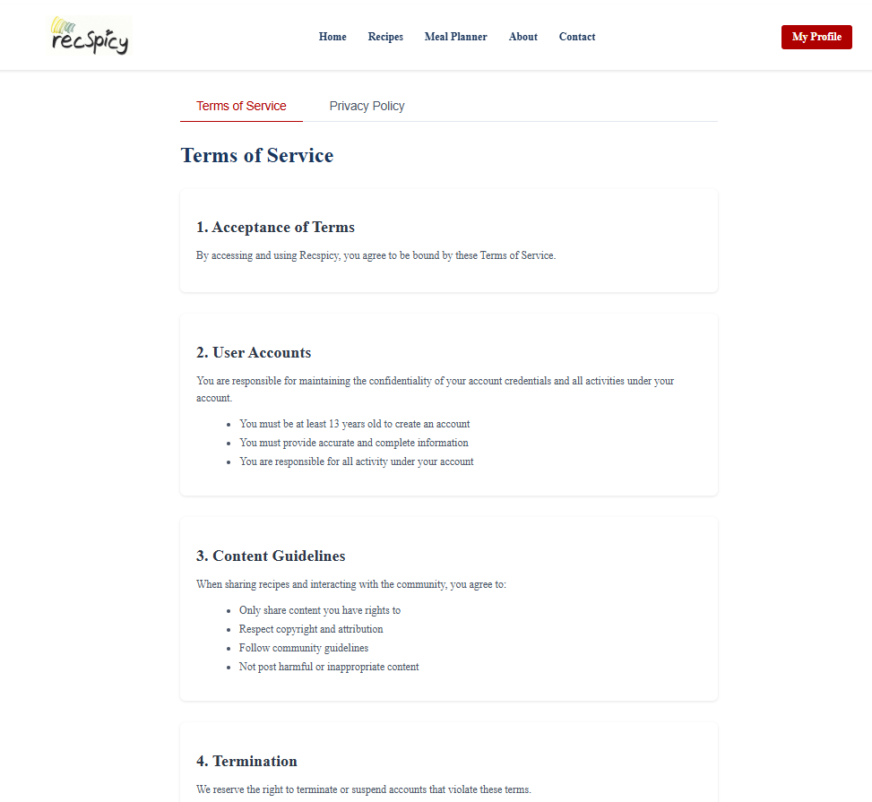

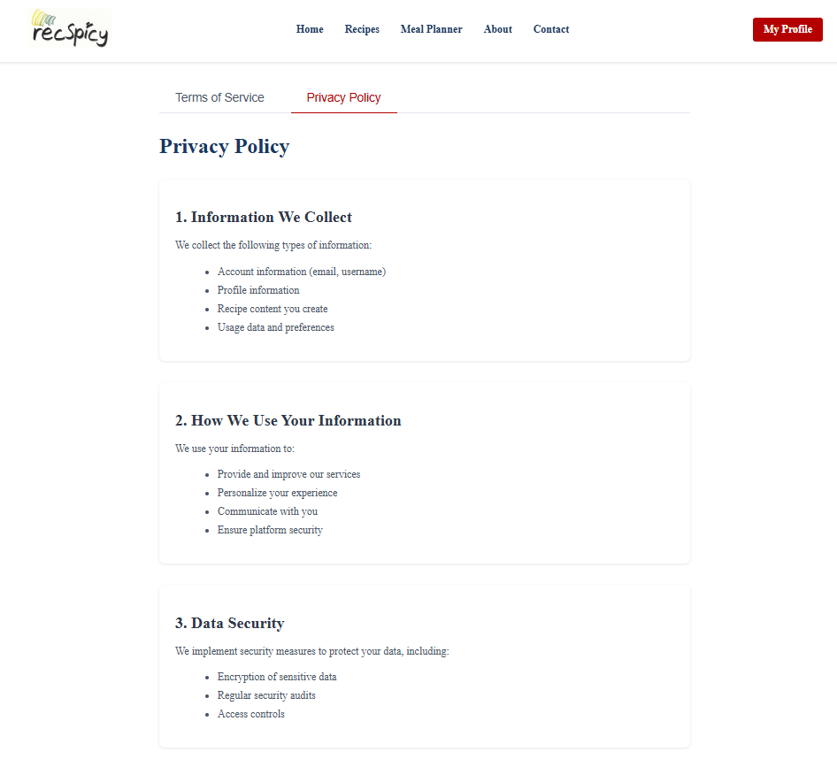

Error Messages
Recspicy employs clear and descriptive error messages to help users understand and resolve issues quickly. Messages are consistently formatted to distinguish between informational, warning, and error conditions. Reference codes are included to assist support staff in diagnosing specific problems. Context-sensitive help links provide immediate access to relevant documentation, and all messages are written in user-friendly language to avoid technical jargon. Accessibility reviews ensure that error messages are understandable to all users.

State of the System as Delivered
At our time of delivery, Recspicy is fully operational with all immediate core features implemented. The system supports secure user registration, recipe management, meal planning, and administrative review. Any known issues or limitations are documented, and users are provided with clear instructions for reporting bugs or requesting assistance. There is an ongoing need for maintenance and support of features available in this project, plans to address these issues are in place for future needs and web platform reliability.

Future Improvements
Enhancements possible for Recspicy include the introduction of social media features that will enable users to share recipes and collaborate on meal plans. Mobile app development can be developed to extend access beyond web browsers,allowing access to the same platform with means of being easy to view access and change across all devices. Artificial intelligence can be utilized in refinement of user created recipes as an assistive tool to better describe and allow for personalized recommendations and automated meal planning. The usage of user feedback will guide the prioritization of new features and improvements.

Appendix

Appendix A: References
This appendix lists the key technologies and frameworks used in the development of Recspicy:
- Express.js for backend routing
- MongoDB for data storage
- Node.js as the runtime environment.

Put Links for official documentation to necessary pieces i.e the platform domain, languages documentation database documentation etc.

Appendix B: Key Terms
Definitions:
- JWT - JSON Web Token
- REST - Representational State Transfer
- CRUD - Create, Read, Update, Delete
Add more as needed

